Twitter Sentiment Analysis using R

# 1. Introduction

Sentiment analysis is a Natural Language Processing (NLP) technique to interpret and classify emotions within textual data. In this project, we use R to analyze sentiments of tweets, making use of libraries like rtweet and tidytext. This analysis helps understand public opinion based on Twitter content.

# 2. Objective

- Fetch and clean Twitter data using R  
- Perform sentiment analysis using the Bing lexicon  
- Classify tweets into positive and negative sentiments  
- Visualize results through sentiment distribution graphs

# 3. Prerequisites

Install the following R packages:  
- rtweet  
- tidytext  
- dplyr  
- ggplot2  
- stringr  
- tidyr

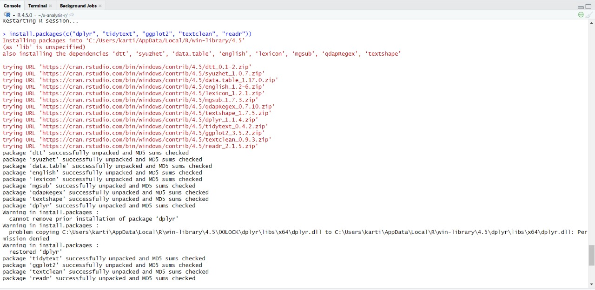

# 4. Load Libraries

library(rtweet)  
library(tidytext)  
library(dplyr)  
library(ggplot2)  
library(stringr)  
library(tidyr)

# 5. Fetch Twitter Data

tweets <- search_tweets("climate change", n = 500, lang = "en", include_rts = FALSE)  
head(tweets$text)

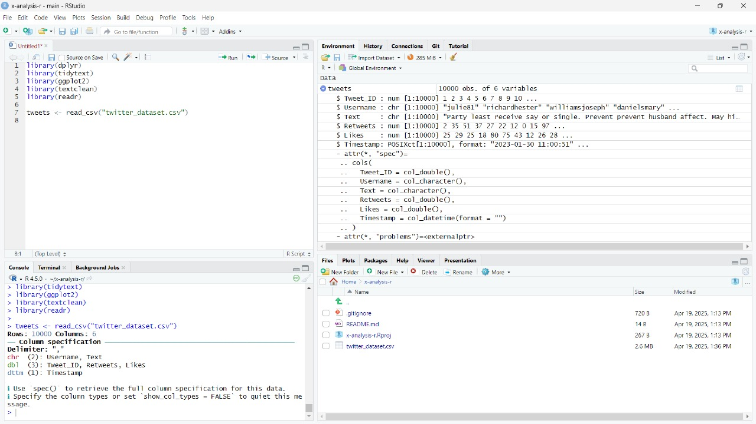

# 6. Preprocess Text and Perform Sentiment Analysis

1. Clean and tokenize text:

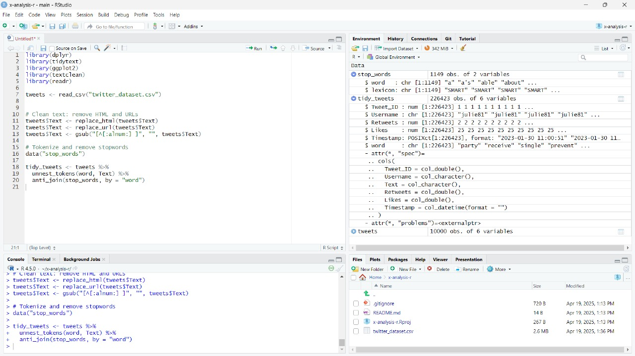

b) Apply sentiment analysis using Bing lexicon:

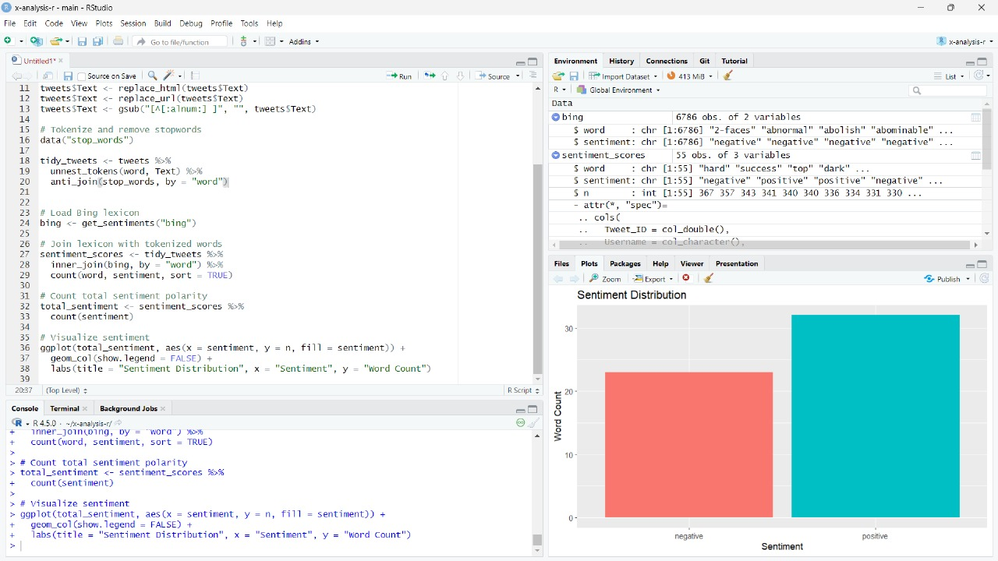

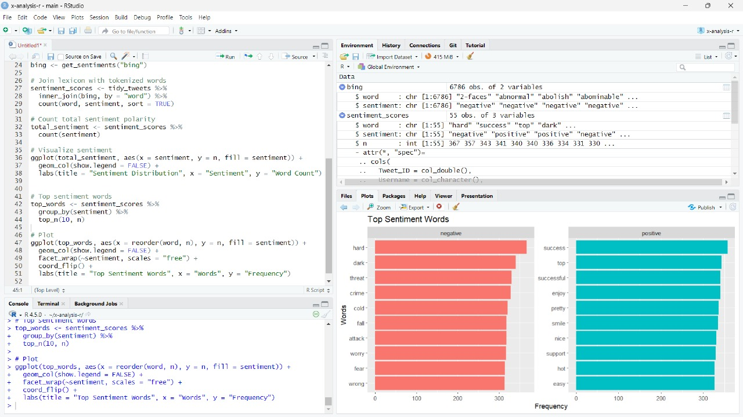

# 7. Visualizing Sentiment Distribution

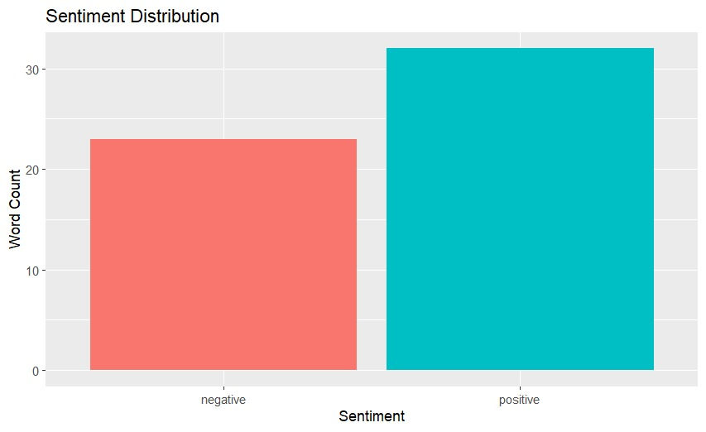

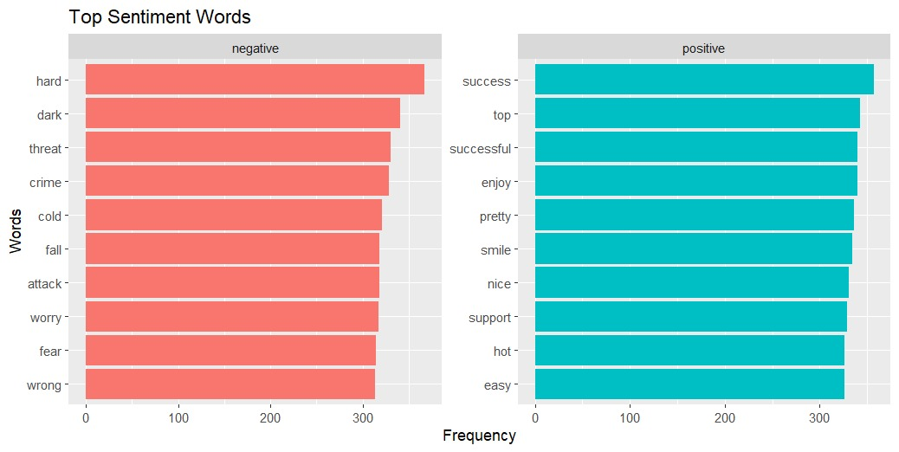

# 8. Conclusion

The project demonstrates how to:  
- Extract Twitter data using rtweet  
- Clean and process text with tidytext  
- Perform sentiment analysis using Bing lexicon  
- Visualize sentiment through plots using ggplot2